Mousse

##### **Yield:** 10 Servings ~6 oz

##### **Prep time:** 30 Minutes (Inactive) + 20 minutes “Cooking”

##### **Total time:** At least 4 Hr, up to a week

# Ingredients

### **Heavy Whipping Cream |** 1 Pint

### **Chocolate |** 2 ½ Cups (I use a blend of semi-sweet, dark; you do you.)

### **Dark Rum |** 1 Shot

### **Salted Butter |** ½ stick

### **Espresso (Optional) |** 2 Shots, or just use another shot of rum 😉

### **Flavorless Gelatin |** Original recipe calls for a teaspoon, I have played around with this a lot, and the measurement is seemingly arbitrary.

# Pre-Cooking Notes

1.) You will need a metal bowl, an electric whisk, and a fridge/freezer. (Or child labor)

2.) You are mixing an accelerant and a depressant; I take no responsibility if you provide this to sensitive/dehydrated/light weight peoples who like to complain about quality food. (I never even taste the alcohol.)

Original Recipe: https://www.foodnetwork.com/recipes/alton-brown/chocolate-mousse-recipe-1951938

# Directions

1.) Put mixing bowl, whisk and ~90% of the Whipping cream into the freezer.  
2.) Begin boiling water for a [double broiler.](https://www.youtube.com/watch?v=6BQ1N40lj3U)   
3.) Place butter, espresso, and rum into melting bowl.  
4.) Microwave remaining 10% of Whipping cream for light frothing; ~20 seconds on high for 1250W Microwave. Add gelatin and mix until blended; you should not see grainy bits.  
5.) Once butter is melted pour in your selection of chocolate into double broiler.  
6.) While chocolate is melting whisk remaining cream to [medium peaks](https://www.google.com/search?q=medium+peaks&tbm=isch&ved=2ahUKEwjVv7-fxbfqAhUFz1MKHQEhC2QQ2-cCegQIABAA&oq=medium+peaks&gs_lcp=CgNpbWcQAzICCAAyAggAMgIIADICCAAyAggAMgIIADICCAAyAggAMgIIADoECCMQJzoECAAQQzoFCAAQsQNQwsAMWKXMDGCmzQxoAHAAeACAAVeIAfMFkgECMTKYAQCgAQGqAQtnd3Mtd2l6LWltZw&sclient=img&ei=OocCX9W6LIWezwKBwqygBg&bih=962&biw=958&client=firefox-b-1-d&safe=active#imgrc=0zkUzwwSbaWnQM).  
7.) When chocolate is mostly melted, with few chunks left, pour in Whipping cream/Gelatin Mix. Remove bowl from double broiler.  
8.) Take 1/3rd of medium peaked whipping cream and mix into chocolate, we do not yet want streaking. **Figure 1.**  
9.) Take 1/3rd of the chocolate/Whipping cream mix and reserve for later 😊  
10.) Fold remaining whipping cream into chocolate in two installments. You can save ~ 10 Tablespoons of chocolate if you are worried you’ll over mix and want to get it just right. **Figure 2.**11.) Set out your 10 glasses/mugs, or 1 I don’t judge, and make a decision. Do you want a chocolate coating, or spiraled mix? If coating, coat now, if mix, mix when pouring it in; it’s easiest while warm, so don’t delay.  
12.) Saran wrap and put in fridge for $≥4 Hrs$. See **Figure 3,** for optimal saran/time ratio.  
13.) Hold yourself off by “Cleaning” the dishes.

# Appendix

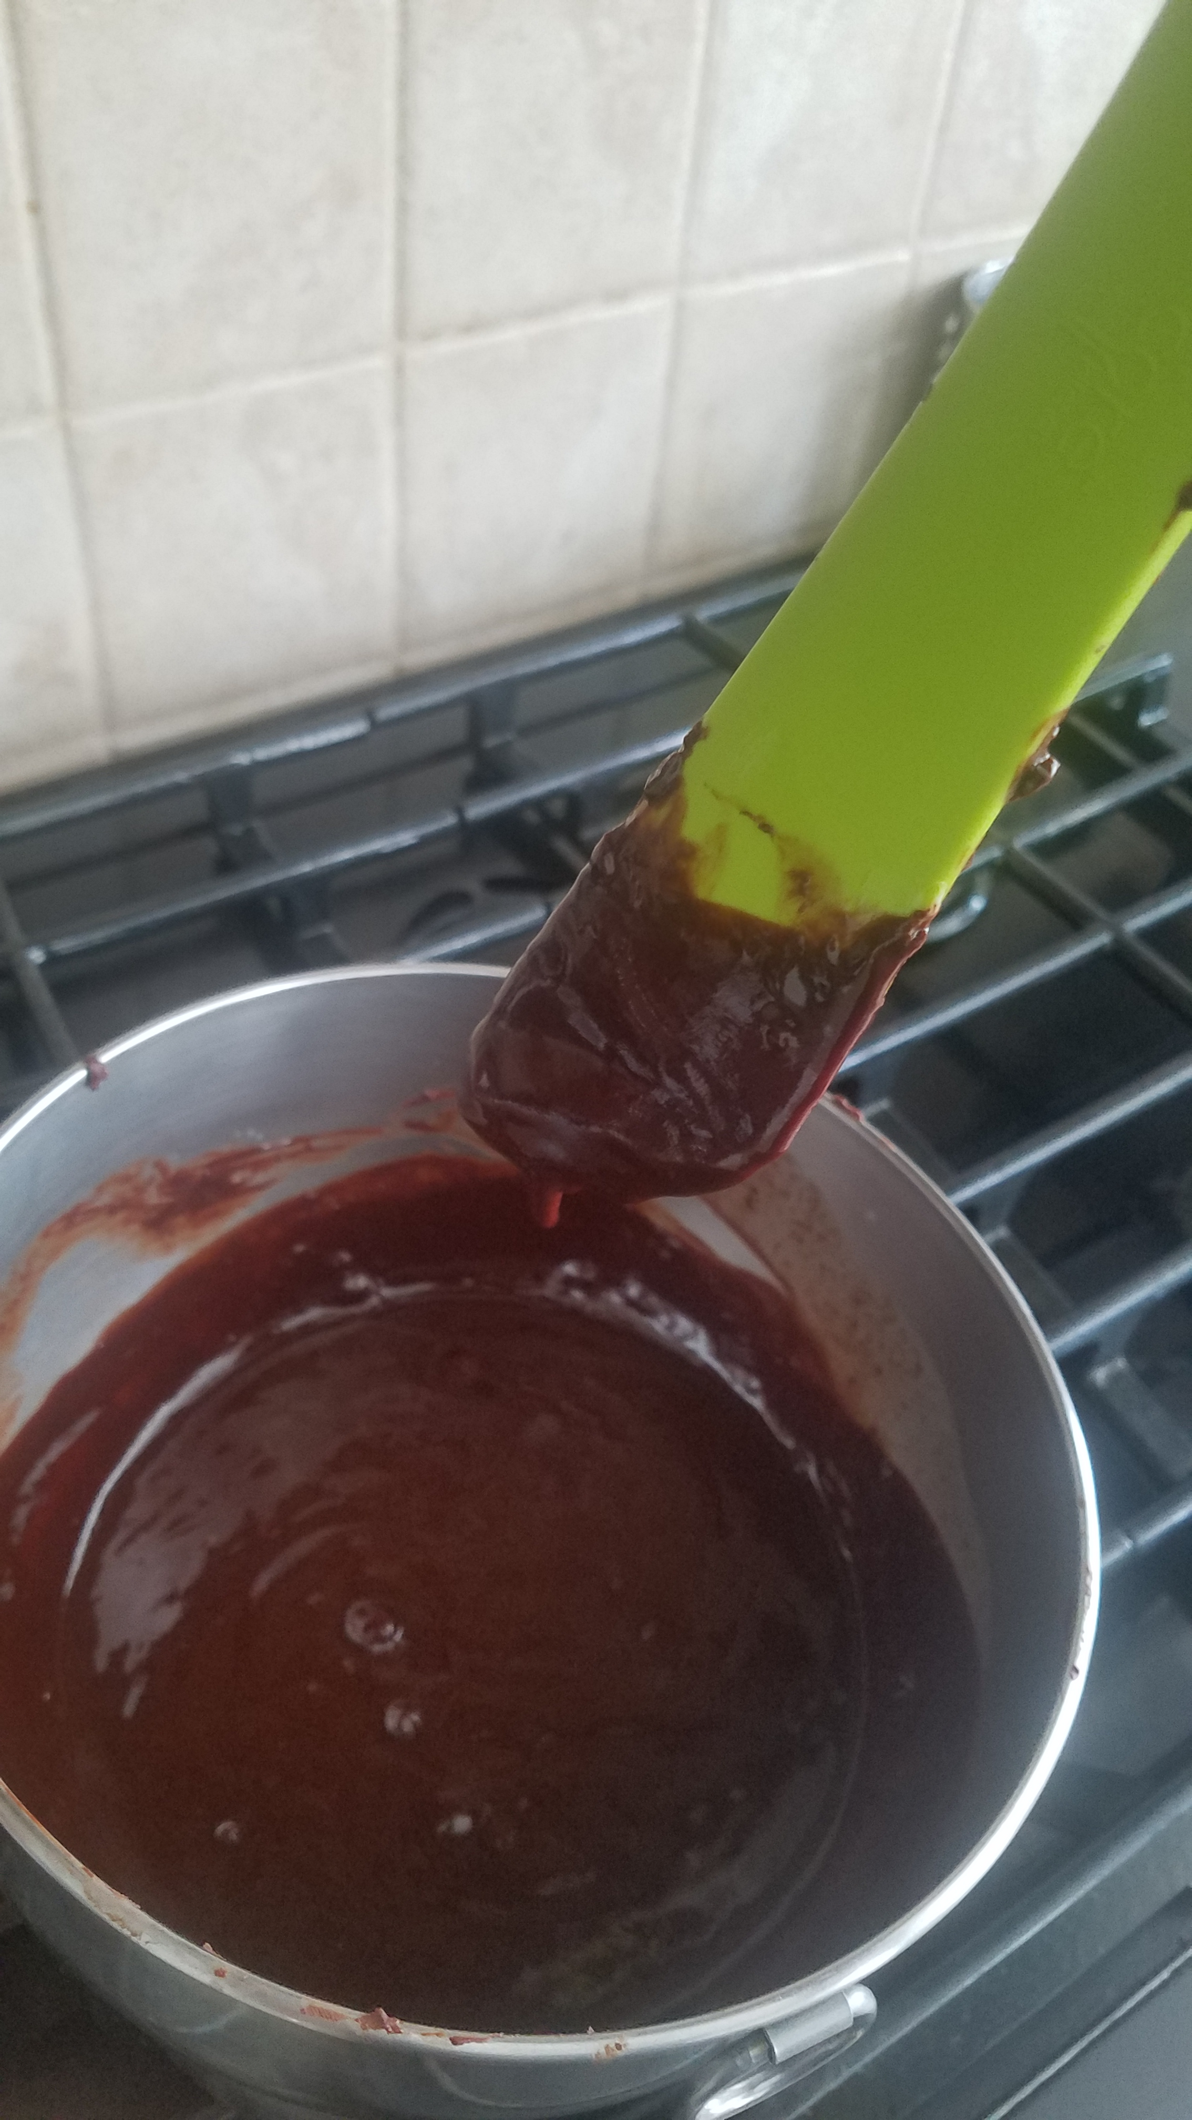

**Figure 1.** Chocolate

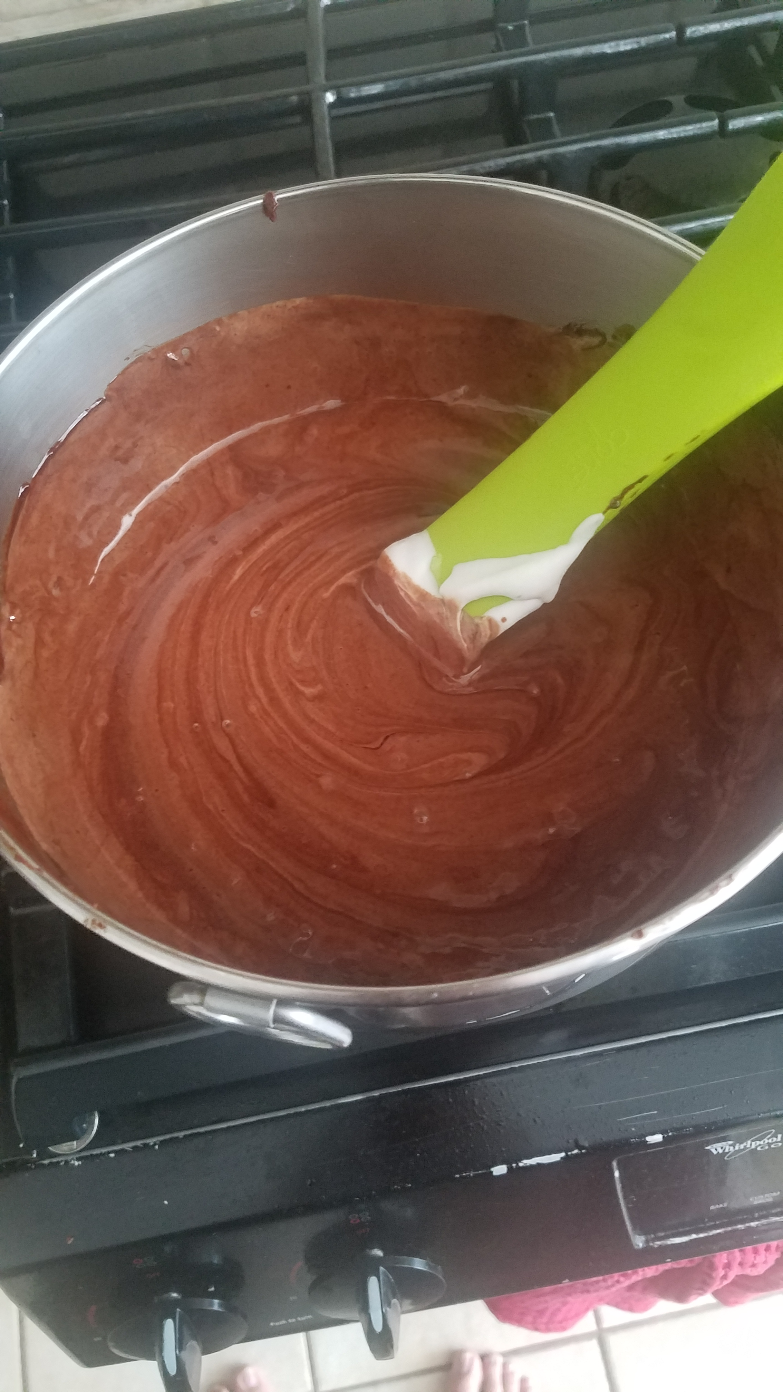

**Figure 2.** Mousse w/ swirl

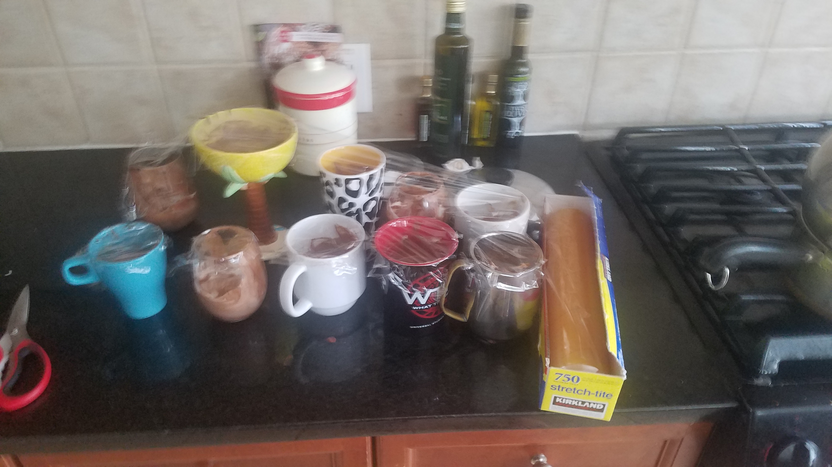

**Figure 3.** Optimal Wrapping Technique; ignoring height variance.